Joyce Yang

Remington – Period 1

**Final Project**

**Lab Description:**

The purpose of this lab is to practice using recursive functions and loops to problem solve. In this lab, the student will be challenged to create a function to pick and plant flowers based on the following criterion listed in the lab goals.

**Before:**

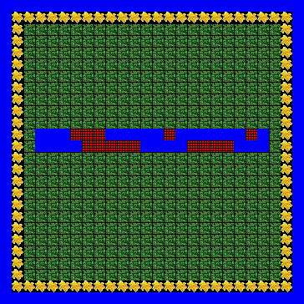

**Lab Goals:**

1. Pick all of the flowers along the border.
2. Plant a flower directly across each square of water. Plant a flower directly two squares across each net.

**After:**

